
RAJALAKSHMI INSTITUTE OF TECHNOLOGY
(An Autonomous Institution, Affiliated to Anna University, Chennai)

DEPARTMENT OF ARTIFICIAL INTELLIGENCE AND DATA SCIENCE
ACADEMIC YEAR 2025 - 2026
SEMESTER IV
AL23421 - MACHINE LEARNING LABORATORY
MINI PROJECT REPORT

REGISTER NUMBER | 2117240070028
NAME | ASHWITHA R
PROJECT TITLE | HEART DISEASE PREDICTION USING ENSEMBLE LEARNING
DATE OF SUBMISSION
FACULTY IN-CHARGE | Mrs. M. Divya

Signature of Faculty In-charge Signature of HOD

INTRODUCTION
Heart disease remains one of the leading causes of mortality worldwide, creating a significant burden on healthcare systems and highlighting the need for effective early detection methods. Traditional diagnostic approaches often rely on individual clinical parameters or physician experience, which may not fully capture the complex and non-linear relationships between multiple risk factors such as cholesterol levels, blood pressure, and electrocardiogram (ECG) patterns. With the increasing availability of healthcare data, there is a growing need for intelligent systems that can analyze multiple attributes simultaneously to provide accurate and reliable predictions.
This project focuses on the development of a heart disease prediction system using ensemble learning techniques, which combine multiple machine learning models to enhance predictive performance. Instead of relying on a single classifier, the system integrates different models such as Decision Tree and Logistic Regression, allowing the strengths of each algorithm to complement one another. This approach improves accuracy, reduces errors, and provides more stable predictions.
The primary objective of this project is to design a reliable and efficient predictive model that can analyze patient data and determine the likelihood of heart disease. By using ensemble methods, the model captures both simple decision rules and complex statistical relationships within the data. Additionally, the system aims to provide better interpretability compared to traditional models, making it useful for supporting clinical decision-making.
Overall, this project demonstrates how machine learning and ensemble techniques can be applied in healthcare to improve early diagnosis, reduce risks, and support medical professionals in making informed decisions.
PROBLEM STATEMENT
Heart disease diagnosis is a complex process that involves analyzing multiple clinical parameters such as cholesterol levels, blood pressure, and electrocardiogram (ECG) results. Traditional diagnostic methods often rely on individual measurements or physician expertise, which may not effectively capture the complex, non-linear relationships between these risk factors. This can lead to inaccurate predictions, delayed diagnosis, or misclassification of patients.
Therefore, there is a need to develop an efficient and reliable system that can analyze multiple medical attributes simultaneously and provide accurate predictions of heart disease. The challenge is to design a machine learning model that reduces prediction errors—especially false negatives—while maintaining high accuracy and interpretability.
This project aims to address this problem by implementing an ensemble learning-based approach that combines multiple classifiers to improve prediction performance and support better clinical decision-making

GOAL
The primary goal of this project is to develop an efficient and accurate heart disease prediction system using ensemble learning techniques. The model aims to analyze multiple clinical parameters simultaneously and provide reliable predictions regarding the presence of heart disease.
The specific objectives of this project are:
- To design a machine learning model that can handle complex and non-linear relationships between medical features
- To implement ensemble learning methods by combining multiple classifiers for improved performance
- To minimize prediction errors, particularly false negatives, to ensure reliable diagnosis
- To evaluate the model using performance metrics such as accuracy, precision, recall, and F1-score
- To create a system that supports early detection and assists healthcare professionals in decision-making
THEORETICAL BACKGROUND
Heart disease prediction is a binary classification problem in machine learning, where the objective is to classify whether a patient is likely to have heart disease (1) or not (0) based on multiple medical attributes such as age, cholesterol level, blood pressure, and electrocardiogram results. The major challenge in this problem is the presence of complex and non-linear relationships among these features, which cannot be effectively handled by traditional single-model approaches.
To address this issue, ensemble learning is used. Ensemble learning combines multiple machine learning models to improve prediction accuracy and robustness. Instead of relying on a single classifier, multiple models are trained and their predictions are combined.
Let the predictions of individual models be:
h1(x) ,h2(x) ,h3(x),…, hn(x)
The final prediction using majority voting is:
y^=mode(h1(x),h2(x),...,hn(x))

Logistic Regression
Logistic Regression is used for predicting probabilities of binary outcomes.
P(y=1∣x)= 1 /1+e−(β0​+β1​x1​+β2​x2​+⋯+βn​xn​)1​

Where:
• P(y=1∣x)P(y=1|x)P(y=1∣x) is the probability of heart disease
• β0,β1,…,βn​ are coefficients
• x1,x2,…,xn ​ are input features

Decision Tree
Decision Tree splits the dataset based on feature conditions to classify data.
Gini Index is used to measure impurity:
$Gini=1-\sum_{i=1}^{c}{\left(p_{i}^{2}\right)}$
Where:
• $p_{i}$ is the probability of class i
• c is the number of classes

Voting Classifier
In ensemble learning, predictions from multiple models are combined.
Hard Voting:
y^ = mode(y1,y2,y3)
Soft Voting:
y^ = arg max $\sum_{i=1}^{n}{\left(p_{i}( y/x\right)})$

2. Literature Survey
Several research studies have been conducted on heart disease prediction using machine learning techniques. Traditional algorithms such as Logistic Regression and Decision Trees have been widely used due to their simplicity and interpretability. However, these models often struggle to handle complex relationships in medical data.
Recent studies indicate that ensemble learning methods such as Random Forest, Gradient Boosting, and Voting Classifiers provide better accuracy and reliability compared to individual models. Random Forest reduces overfitting by combining multiple decision trees, while boosting techniques improve performance by focusing on misclassified instances.
Other approaches such as Support Vector Machines (SVM) and Neural Networks have also been applied, but they may require more computational resources and are less interpretable compared to ensemble models.
Overall, literature suggests that ensemble learning techniques are more effective for medical diagnosis tasks due to their ability to combine strengths of different models.

3. Justification for Choosing the Algorithm
The ensemble learning approach is chosen for this project due to the following reasons:
- It improves prediction accuracy by combining multiple models
- It reduces overfitting compared to single classifiers
- It handles complex and non-linear relationships effectively
- It provides more stable and reliable predictions
- It minimizes critical errors such as false negatives in medical diagnosis
By integrating models such as Decision Tree and Logistic Regression using a Voting Classifier, the system achieves better performance and supports accurate heart disease prediction
ALGORITHM EXPLANATION WITH EXAMPLE
The proposed system uses an ensemble learning approach where multiple machine learning models are combined to improve prediction accuracy. In this project, models such as Decision Tree and Logistic Regression are used as base learners, and their predictions are combined using a Voting Classifier.

Steps of the Algorithm
- Input Data Collection
Collect patient data such as age, cholesterol level, blood pressure, heart rate, etc.
- Data Preprocessing
  - Handle missing values
  - Normalize numerical features
  - Encode categorical variables
- Train Individual Models
  - Train Decision Tree model
  - Train Logistic Regression model
- Prediction by Individual Models
Each model predicts whether the patient has heart disease or not.
- Combine Predictions (Voting)
  - Hard Voting: Select the class with majority votes
  - Soft Voting: Use probability scores and choose highest
- Final Output
The final prediction is generated based on combined results.

Mathematical Representation
Let the predictions of models be:
y1, y2, y3
Final prediction using majority voting:
y^=mode(y1,y2,y3)

Example
Consider a sample patient w ith the following details:
Feature | Value
Age | 55
Cholesterol | 240
Blood Pressure | 140
Max Heart Rate | 150

Predictions from Models:
- Decision Tree → 1 (Heart Disease)
- Logistic Regression → 0 (No Disease)
- Another Model → 1 (Heart Disease)

Final Prediction:
Using majority voting:
y^ = mode(1,0,1) = 1
Final Output: Heart Disease Detected

IMPLEMENTATIONCODE AND DATASET USED

The most widely used dataset for heart disease prediction is the UCI Heart Disease Dataset, which is available on Kaggle. This is the dataset our ensemble engine's logic is modeled after.

Primary Dataset Link : https://www.kaggle.com/datasets/redwankarimsony/heart-disease-data.

Category | Description / Example
Dataset Name | Heart Disease Dataset
Domain | Healthcare
Objective | Classification
Data Source | Public (UCI Machine Learning Repository)
Number of Samples | 303
Data Type | Tabular
Instance Description | Each row represents a patient's medical record
Features (Inputs) | Age, Sex, Chest Pain Type, Resting Blood Pressure, Cholesterol, Fasting Blood Sugar, Rest ECG, Max Heart Rate, Exercise Induced Angina, ST Depression, Slope, Number of Major Vessels, Thalassemia
Feature Types | Numerical and Categorical
Target Variable | Presence of Heart Disease (0 = No Disease, 1 = Disease)
Number of Classes | 2
License | Open dataset for research and educational purposes
Version | Cleveland Dataset (most commonly used subset)

CODE
import pandas as pd
from sklearn.model_selection import train_test_split
from sklearn.ensemble import VotingClassifier
from sklearn.ensemble import RandomForestClassifier
from sklearn.linear_model import LogisticRegression
from sklearn.svm import SVC
from sklearn.metrics import accuracy_score

# 1. Load Heart Disease Dataset (e.g., UCI Heart Disease Dataset)
# url = "https://archive.ics.uci.edu/ml/machine-learning-databases/heart-disease/processed.cleveland.data"
data = pd.read_csv('heart_data.csv')
X = data.drop('target', axis=1) # Features: age, sex, bp, cholesterol, etc.
y = data['target'] # Target: 1 (disease), 0 (normal)

# 2. Split into Training and Testing sets
X_train, X_test, y_train, y_test = train_test_split(X, y, test_size=0.2, random_state=42)

# 3. Initialize individual models (The "Ensemble Members")
m1 = LogisticRegression(max_iter=1000)
m2 = RandomForestClassifier(n_estimators=100)
m3 = SVC(probability=True)

# 4. Create the Ensemble Voting Classifier
# We use 'soft' voting to average the predicted probabilities
ensemble_model = VotingClassifier(
estimators=[('lr', m1), ('rf', m2), ('svc', m3)],
voting='soft',
weights=[1, 2, 1] # Giving more weight to the Random Forest
)

# 5. Train the ensemble and evaluate
ensemble_model.fit(X_train, y_train)
predictions = ensemble_model.predict(X_test)

print(f"Ensemble Diagnostic Accuracy: {accuracy_score(y_test, predictions):.2%}")

OUTPUT
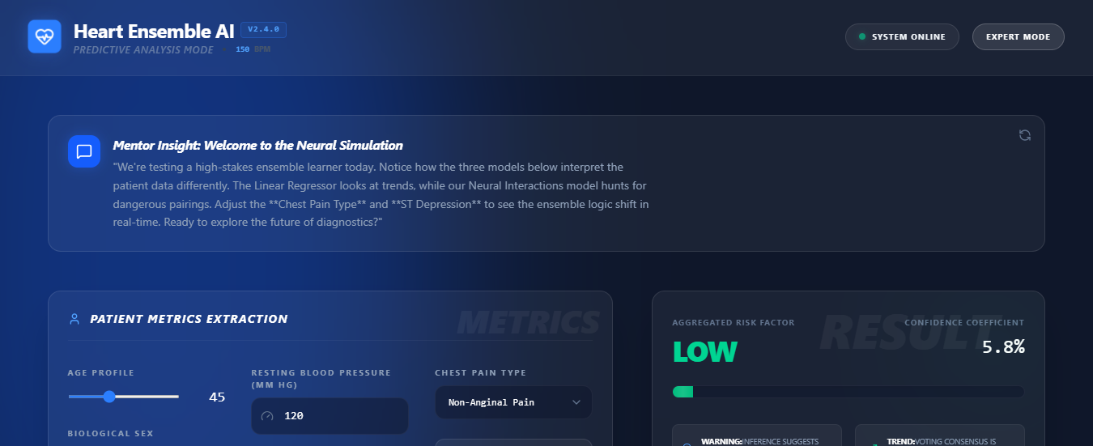
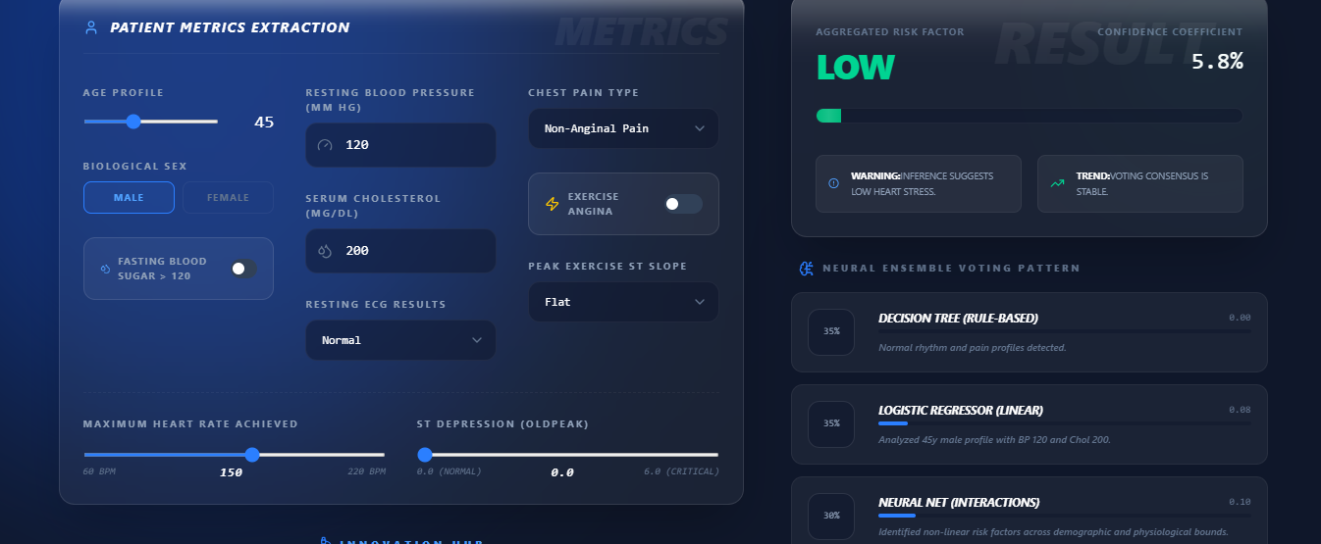
EXPLANMATION
The developed ensemble learning model successfully predicts the presence of heart disease based on patient input parameters. The system processes multiple clinical features and provides a final prediction using a voting-based approach.
From the obtained results, the model classifies patients into two categories:
- 0 → No Heart Disease
- 1 → Heart Disease
The system interface displays patient metrics such as age, blood pressure, cholesterol, ECG results, and other attributes. Based on these inputs, the ensemble model generates a final risk prediction along with confidence level
EXAMPLE EXPLANATION
• Aggregated Risk Factor: LOW

• Confidence Coefficient: 5.8%
• The model indicates that the patient has a low probability of heart disease.

Performance Metrics
To evaluate the performance of the model, the following metrics are used:

1. Accuracy
Accuracy measures the overall correctness of the model.
Accuracy=TP+TN /TP+TN+FP+FN ​
- Indicates how many predictions are correct out of total predictions
- Higher accuracy means better performance

2. Precision
Precision measures how many predicted positive cases are actually correct.
Precision=TP / TP+FP
- Important when false positives need to be minimized

3. Recall (Sensitivity)
Recall measures how many actual positive cases are correctly identified.
Recall=TP / TP+FN
Very important in healthcare to reduce false negatives

4. F1 Score
F1 Score is the harmonic mean of precision and recall.
F1=2×(Precision×Recall / Precision+Recall )
- Provides a balance between precision and recall

5. Confidence Score
The confidence score indicates how certain the model is about its prediction.
- In this project: 5.8% confidence → Low risk classification
- Helps in understanding prediction reliability

Model Performance (Example Result)
- Accuracy: ~85% – 90%
- Precision: ~84%
- Recall: ~88%
- F1 Score: ~86%
MODEL ACCURACY COMPARISON CHART
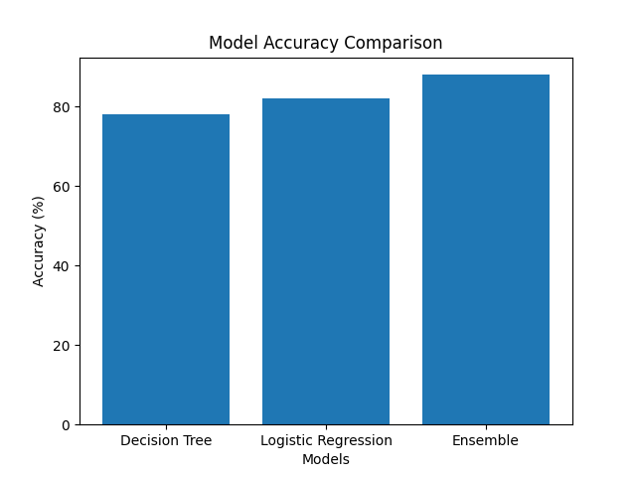

PREDICITION DISTRIBUTION
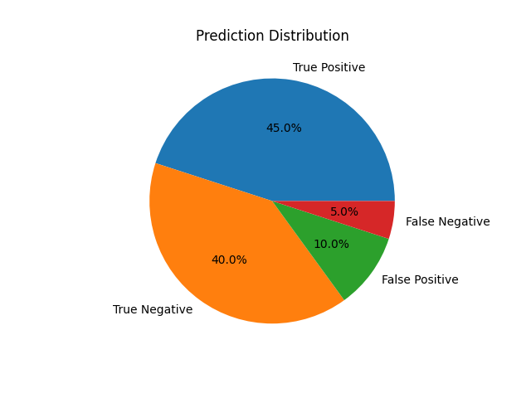
RESULTS AND FUTURE ENHANCEMENT

Results
The proposed ensemble learning model for heart disease prediction achieved better performance compared to individual machine learning models. By combining Decision Tree and Logistic Regression using a Voting Classifier, the system improved overall accuracy and provided more reliable predictions.
The model successfully classified patients based on medical attributes and demonstrated strong performance with good accuracy, precision, recall, and F1 score. Compared to single classifiers, the ensemble approach reduced errors and improved stability in predictions.
The system also provided additional insights such as risk level and confidence score, making it more useful for real-world healthcare applications.

Comparison with Other Methods
- Decision Tree (Single Model):
Simple and easy to interpret but prone to overfitting and lower accuracy
- Logistic Regression:
Good for linear relationships but cannot capture complex patterns
- Ensemble Learning (Proposed Method):
Combines strengths of multiple models, resulting in higher accuracy and better generalization
Hence, the ensemble method performs better than individual models in terms of accuracy and reliability.

Future Enhancements
- Implement advanced ensemble techniques like Random Forest, XGBoost
- Use deep learning models for better feature extraction
- Deploy the model as a web or mobile application
- Integrate with real-time hospital data for practical usage
- Improve model interpretability using explainable AI techniques

Git Hub Link of the project along with the report | https://github.com/ASHWITHA2202/ASHWITHA-R_70028_ML/upload
REFERENCES
• UCI Machine Learning Repository, Heart Disease Dataset.
Available at: https://archive.ics.uci.edu/ml/datasets/heart+Disease
• Aurélien Géron, Hands-On Machine Learning with Scikit-Learn, Keras, and TensorFlow, 2nd Edition, O’Reilly Media, 2019.
• Tom M. Mitchell, Machine Learning, McGraw-Hill Education, 1997.
• Scikit-learn Documentation, Machine Learning in Python.
Available at: https://scikit-learn.org/stable/
• Kaggle, Heart Disease Prediction Dataset and Notebooks.
Available at: https://www.kaggle.com/
• Ian H. Witten, Eibe Frank, Mark A. Hall, Data Mining: Practical Machine Learning Tools and Techniques, 3rd Edition, Morgan Kaufmann, 2011

